**Checkpoint 4:**

Hyukjoon Yang, Tae Yong Namkoong, & Nate Sackett

**STORED PROCEDURES & Interface**

**1.** Updates the global (total) sales of a game based on regional values

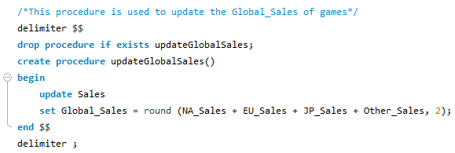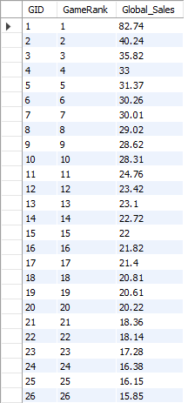**→**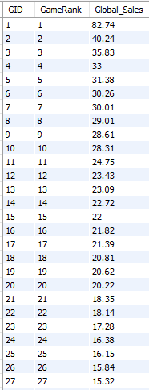

**2.** Helper procedure for updateRank

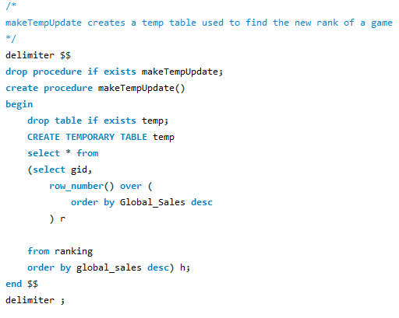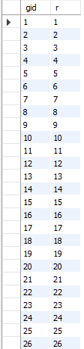

**3.** Update rank when global sales data updated

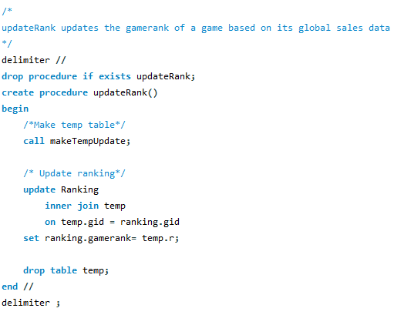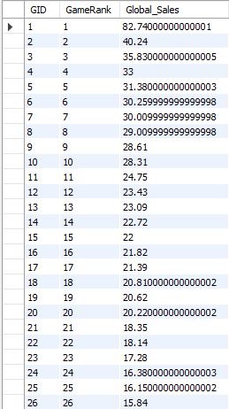

**4.** Search

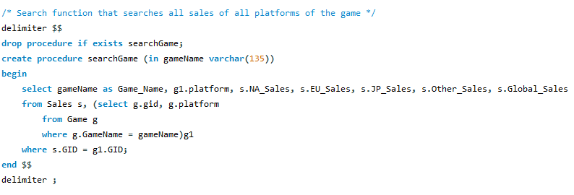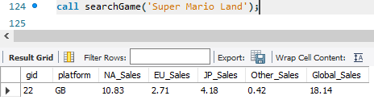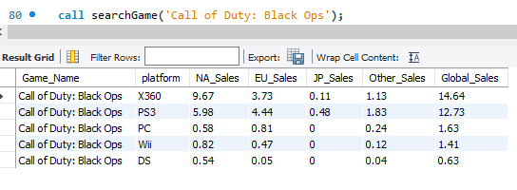

**5.** Insert

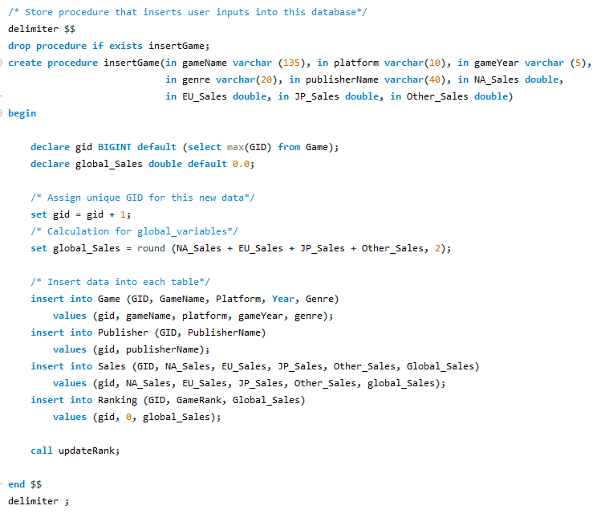

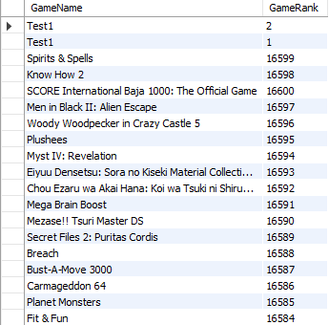

**LEVEL 1 QUERIES & Interface**

1. 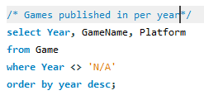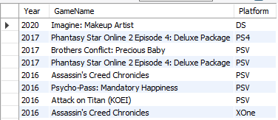
2. 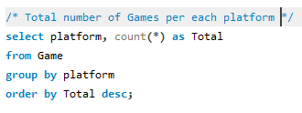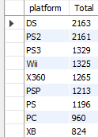

**LEVEL 2 QUERIES & Interface**

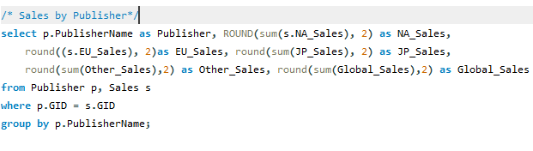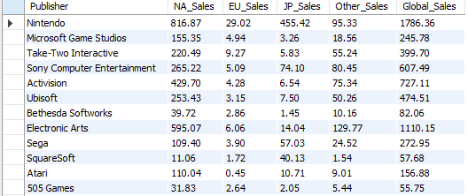

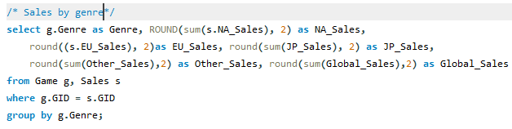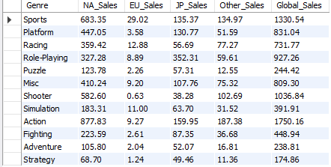

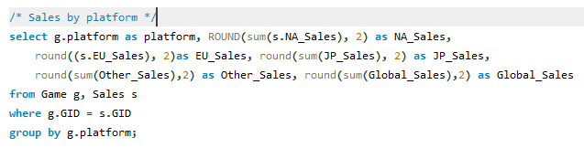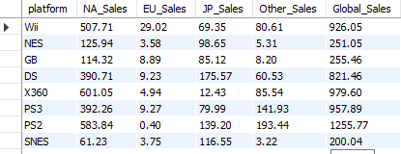

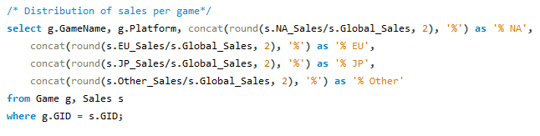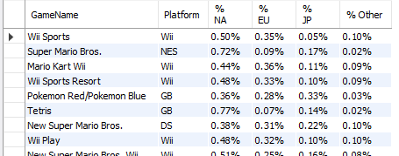

**2. Interface:** See above for actual implementation/output results which shows the screens of asking queries over the base (insert/delete/modify data)

Below is a diagram showing a mock-up user-interface. Our interface will utilize all functions embedded in the back-end with a set of buttons and textfields on a panel to enhance user experience at the front-end.

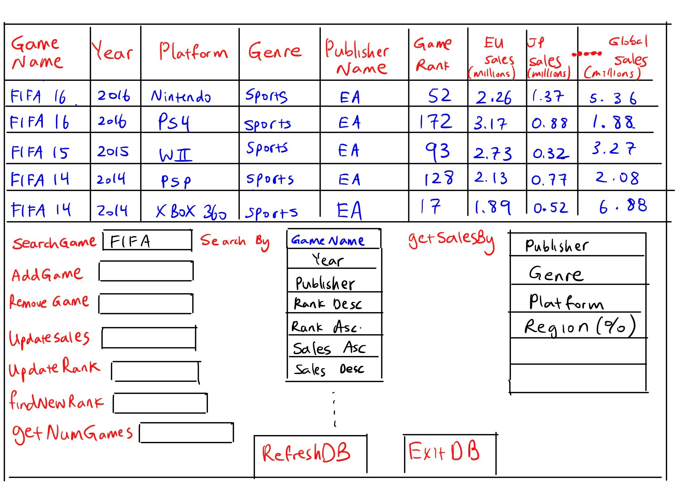

**3. Evaluation**

Describe how you plan to test your application. That includes (i) objectives of the evaluation (ii) at least 5 test cases to test each objective (iii) how do we evaluate these test cases.

Objectives of the evaluation: Make sure that games can be added, removed, searched for, global sales correctly increases upon incrementing regional sales, and rank will update after changing sales data.

1. Test that Global sales increases when the sales data in any region is incremented
   1. Search for ‘Wii Sports Resort’ and find current sales data:

|  |  |  |  |  |  |
| --- | --- | --- | --- | --- | --- |
| **Name** | **NA_Sales** | **EU_Sales** | **JP_Sales** | **Other_Sales** | **Global_Sales** |
| Wii Sports Resort | 15.75 | 11.01 | 3.28 | 2.96 | 33 |

* 1. For each region:
     1. increment the sales by 1
     2. run updateGlobalSales()
     3. check that Global Sales has increased by one
     4. decrement regional sales
     5. run updateGlobalSales() again
     6. check that Global Sales has returned to its original value.

1. Test that rank updates for a game after sales in changed
   1. Increase value of NA_Sales for ‘New Super Mario Bros.’ by 1.5
   2. Run stored procedures: updateGlobalSales, makeTempUpdate, and updateRank
   3. Check if GameRank is now 5 and NA_Sales is now 12.88
2. Test adding a game:
   1. Add Minecraft (all versions) to the list and check that the ranks are correctly formatted:

|  |  |  |  |  |  |  |  |  |  |
| --- | --- | --- | --- | --- | --- | --- | --- | --- | --- |
| **Name** | **Platform** | **Year** | **Genre** | **Publisher** | **NA_Sales** | **EU_Sales** | **JP_Sales** | **Other_Sales** | **Global_Sales** |
| Minecraft | PC/Java | 2009 | Sandbox | Mojang | 41 | 36 | 51 | 82 | 210 |
| Minecraft | Console | 2011 | Sandbox | Mojang | 40 | 35 | 19 | 82 | 176 |
| Minecraft | Pocket/Windows | 2011 | Sandbox | Mojang | 19 | 29 | 30 | 36 | 114 |

* 1. Run updateGlobalSales, makeTempUpdate, and updateRank
  2. Minecraft should be successfully added
  3. Ranks should be 1, 2, 3

1. Search a game by its GameName and check whether the corresponding platforms are returned
2. Call searchGame(‘Call of Duty: Black Ops’) 
3. Check whether the returned platforms correspond to each GameName
4. Check that deleting a game correctly decreases count
   1. Check the current count of games (16598 at start)
   2. Fully join all tables on GID
   3. Delete every instance of ‘Call of Duty: Black Ops’
   4. Check that count is now 5 less (16593 if starting values used)